Joey Carnicle

7/17/20

Lab 4 Writeup

**Problem 1:**

1. 

LSUSB shows the connections made through the USB buses. Here we recognize the Logitech C615 on Bus 1.

1. 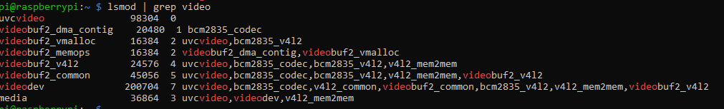

LSMOD shows the kernel modules that are loaded. Here the UVC video module has loaded appropriately for the webcam.

1. 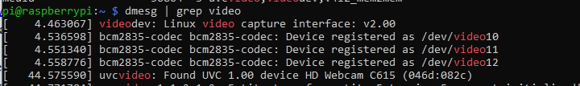

Dmesg displays the kernel ring buffer data for external interfacing. Here we search for video and see that the uvcvideo has found the C615 webcam.

1. Included in A, B, & C above.

**Problem 2:**

1. 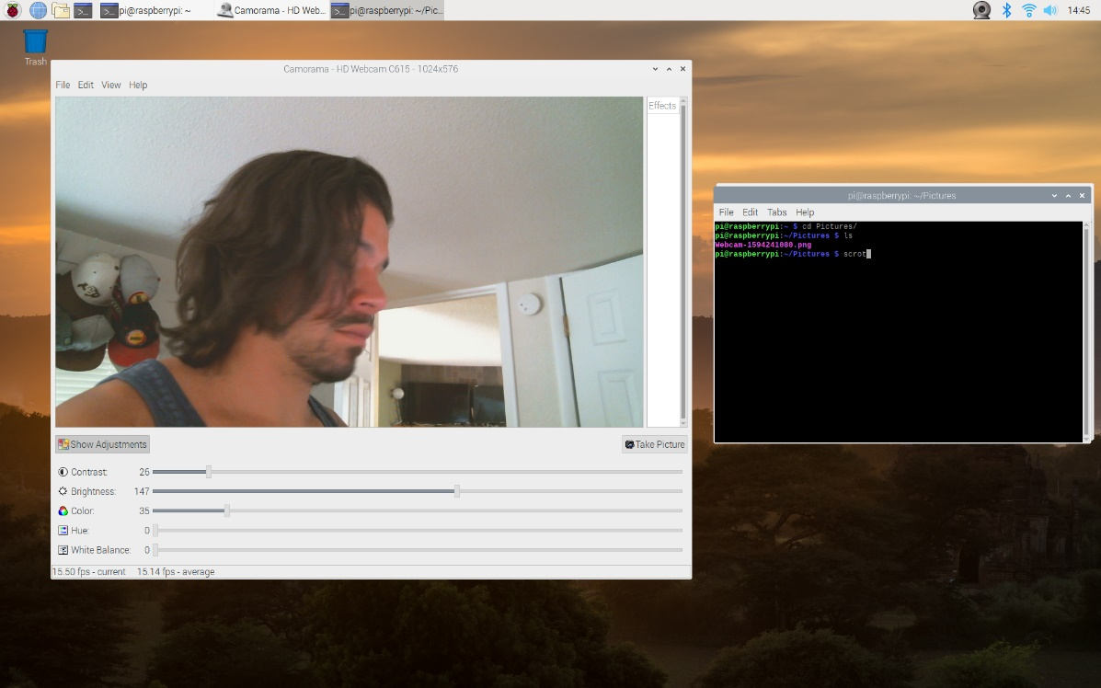

Screenshot of Camorama GUI.

1. 

Camera shot via Camorama using the C615 webcam.

**Problem 3:**

1. Screenshot of running the capture code: A screenshot of a computer

   Description automatically generated
2. I really enjoy learning the low level capture so I didn’t not explore OpenCV.

**Problem 4:**

1. Screenshot of the sharpen code:

1. The sharpen code is shifting each R, G, & B stored in the input PPM file and storing it in the output PPM file that the user inputs. The code opens the PPM file and steps through each pixel R, G, & B and uses the point spread function to sharpen each pixel, which it stores in convR, convG, & convB arrays and then writes these variables to the output PPM file.

Continuous transformation can be useful for various functions which include compression for storage of the files, recognition of changes in the file and altering system function, & continuous streaming with alteration to the initial camera picture (or any streaming technology).

1. Below is the screenshot of running the code captureupdate.c located in the github folder. The frame rates are logged using the syslog function. I added the sharpen transformation in the process_image function after the YUYV is converted to RGB. The sharpen code is largely copied from the provided code, but updated to run through the bigbuffer[] array of RGB values and sharpen each with the PSF.

The average frame rate after the sharpen code is added is very slow, around 1 second (each log subtracts that frame time from the start time, so they are cumulative). I was unable to get this transformation to run much faster than this, I think this is best run as a post processing thread rather than continuous transformation.

**Problem 5:**

1. For this problem I chose to analyze YUYV to RGB, YUYV to RGB + sharpen, and YUYV to YY (Greyscale) at 640x480, 320x240, and 80x60 resolutions. The three cases are run in order for 30 frames each for a total of 90 frames at each resolution. This is the captureupdate2.c code in the github folder. The screenshots from the 3 resolutions are below:

320X240:

80x60:

680x460:

The average frame rate for each:

320x240:

RGB –39025 usec

RGB + Sharpen = 1195000 usec

Greyscale = 28526 usec

80x60:

RGB – 40465 usec

RGB + Sharpen = 1170475 usec

Greyscale = 27991 usec

640x480:

RGB – 39496 usec

RGB + Sharpen = 1205698 usec

Greyscale = 28988 usec

So the total averages are:

RGB – 39.67 msec

RGB + Sharpen = 1190.40 msec

Greyscale = 28.51 msec